080419Android Sticky Scheduler
Use Case Diagram

Submitted to:

Prof. Ma. Rowena C. Solamo
Faculty Member
Department of Computer Science
College of Engineering
University of the Philippines, Diliman

Submitted by:
Buera, Louie
Cabiles, Miguel
Palaganas, Genesis Ian

In partial fulfillment of Academic Requirements
for the course
CS 191 Software Engineering I
of the
1st Semester, AY 2014-2015
Revision Control

History Revision:
Revision Date | Person Responsible | Version  Number | Modification
09/10/14 | Miguel Cabiles | 1.0 | Initial Document; Version number should match the one below.

System Name: 080419Android Sticky Scheduler

Description: As the project name suggests it is a scheduler for the android platform. It aims to assists students specially in the collegiate level to manage their time. It's core features are as follows: Scheduler, Calendar integration and Location Based Functionalities.

Use-Case Diagram:

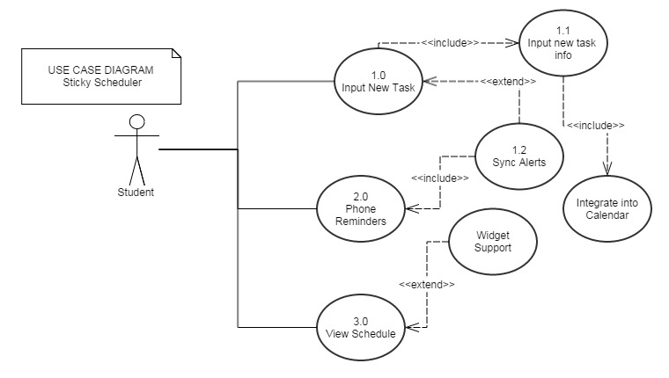

List of Actors:
Actors | Description
Student | This actor represents the user of the software. The student inputs information about the schedule, with the option of adding notes and enabling location-based alerts.

List of Use-cases:
Use-Case | Description
Use-Case 1.0 Input New Task | The user inputs information about a new task. When a task has been input, the application should integrate the task into the phone calendar.
Use-Case 1.1 Input New Task Info | The user would input the task name, time and date when it is to be accomplished, location where it is to be done. Notes may also be added.
Use-Case 1.2 Sync Alerts | The user would input when he wants to be reminded of the task via phone notifications. This includes the time, date and possibly the place when the task should be done.
Use-Case 2.0 Phone Reminders | The software should alert the user at the time when the user set the alert for a certain task.
Use-Case 3.0 View Schedule | The user may view the list of tasks through an interface either within the app itself or through widget support.

